Restore test
04/11/2026

1. Version history after updating original text file.

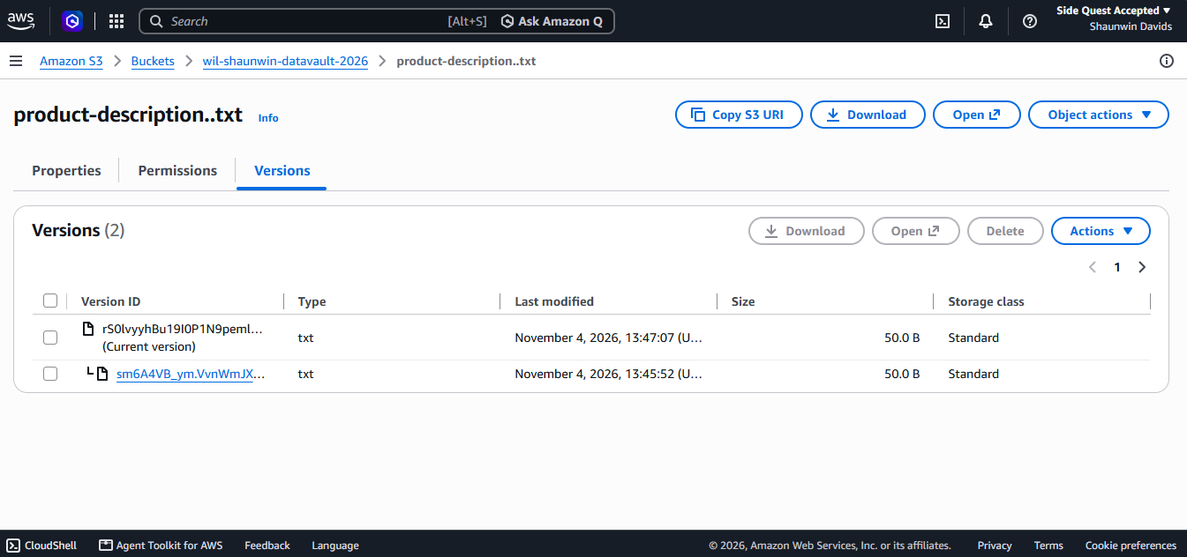

2. Version History after Downloading and uploading original text file.
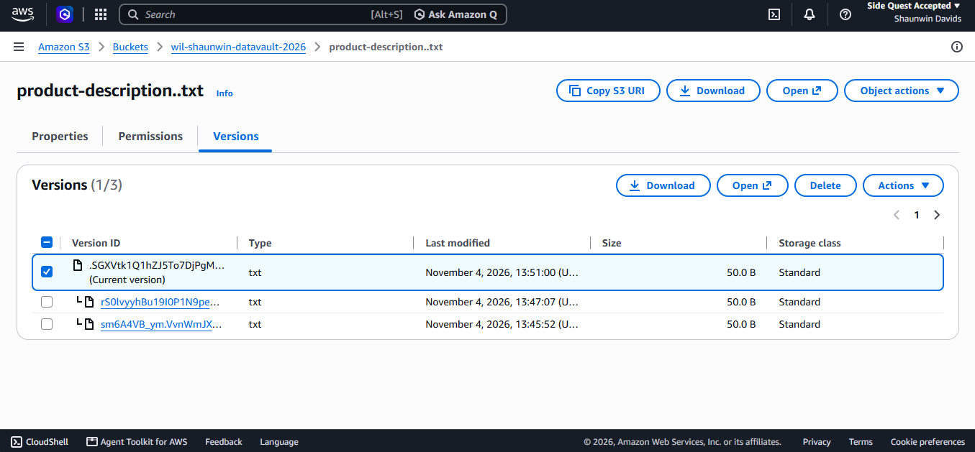

3. Content that the orinigal text file contain.

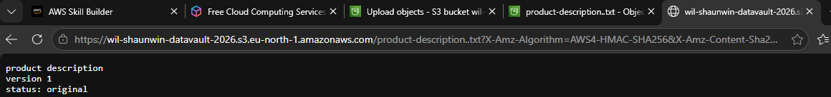

AWS S3 Recovery Runbook
Project: WIL-2026
Service: Amazon S3
Test object: customer-records.txt
Purpose: Test recovery using S3 object versioning.
Recovery procedures:
- Sign in to the AWS Management Console and open Amazon S3.
- Open the WIL Data Vault bucket and locate customer-records.txt.
- Confirm that bucket versioning is enabled.
- Upload the original customer-records.txt file.
- Modify the file and upload it again using the same object key to simulate an accidental overwrite.
- Enable Show versions to display the previous and latest versions.
- Identify and download the original version of the file.
- Upload the downloaded original file again using the same filename.
- Check the version history and confirm that a new latest version has been created.
- Download the latest version and verify that it contains the original information.
Expected outcome:
The original file was recovered successfully, and the previous versions remained available in Amazon S3. This demonstrates how versioning can help protect important project files against accidental changes or overwrites.

